***Anticonvulsant or Antiepileptic drugs***

**They are drugs used for prevention and control of epileptic seizures.  
* GABA is the main inhibitory transmitter in the brain.   
* Glutamate & Aspartate Excitation = Excitatory transmitter (NMDA).**

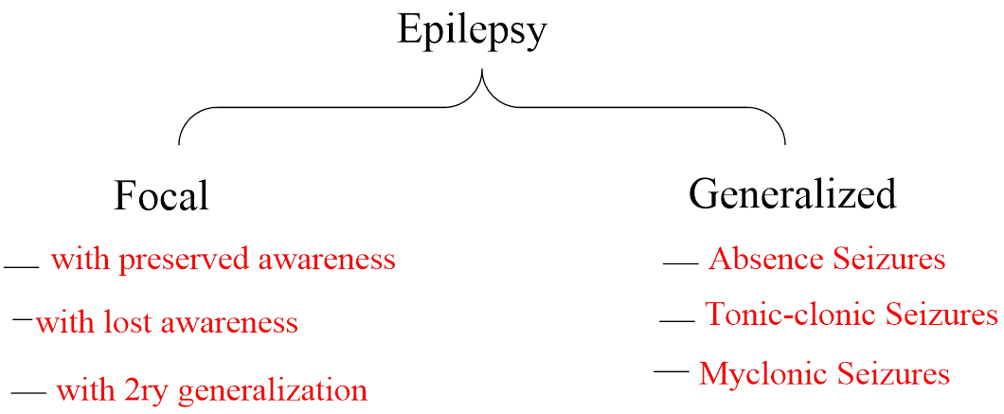

**Suggested mechanisms for treating epilepsy:**

**\* Enhancement GABA Inhibitory transmitter receptors.**

**\* Inhibitory Exatotary transmitter Glutamate and Aspartate receptors.**

**\* Block Na+ -Channels**

**( for tonic-clonic, focal seizures only not for Absence seizures)**

**\*Block T-Type Ca2+ -Channels ( mechanism of Absence seizures )**



1. **Barbiturates**



**Both agents are effective against generalized tonic—clonic and focal seizures.**

1. **Hydantoins**



1. **Phenytoin**



**b- Mephenytoin**



**It was introduced as a sedative-hypnotic and anticonvulnant under the name Nirvanol, but it was withdrawal because of toxicity.**

**S/E:-Serious skin and blood disorders**

**c- Ethotoin**



**It is used against generalized seizures.**

1. **Oxazolidinediones**

**They are prepared by isosteric replacementof the N-H group at position I of the hydantoin**

**system with an oxygen atom yields the oxazolidine-2,4-dione system. They are effective in Absence seizures, but ineffective in clonic-tonic seizures.**

**Trimethadione**



1. **Succinimides**

**They are prepared by isosteric replacementof the O group at position 1 of oxazolidine-2.4-dione system with CH2 yields the succinimides.**

**a- Phensuximide**





**Methsuximide**



**It has some use against absence and complex focal seizures.**

1. **Ethosuximide**



**It has antiabsence activity(more selective block T-Type cell Ca2+ - Channel ). The drug is more active and less toxic than trimethadion. It is a calcium T channel—blocking drug. Toxicity primarily involves the skin and blood.**

1. **Miscellaneous Agents**
2. **Urea and monoacylureas**

**Carbamazepine and oxcarbazepine .**

1. **Carbamazepine**



**Mechanism of action: - sodium channel block**

**Uses: - Carbamazepine is useful in generalized tonic—clonic and focal seizures.**

**S/E: - produce aplastic anemia (epoxide metabolite)**

1. **Oxcarbazepine**



**Mechanism of action: - sodium channel block**

**Uses: - active against Focal seizures.**

**S/E: - not produce a plastic anemia ( not give epoxide metabolite)**

1. **Primidone**



**It is a 2-deoxy analog of Phenobarbital, used to control of tonic-clonic seizures and psychomotor epilepsy. It is oxidized in the body to pheobarbital.**

1. **Valproic Acid**



**Valproic acid has good potency and is used against several seizure types (tonic-clonic seizures**

**and Absence seizures).**

**_ so enhancement GABA inhibitory transmitter , block Na+-channels and block Ca2+ -channels**

**But not exatatory glutamate and aspartate.**

**_ Microsomal enzyme inhibition .**

1. **Gabapentin**



**Gamma aminobutyric acid**

**It was introduced for adjunctive therapy of refractory focal seizures and, secondarily, generalized tonic—clonic seizure.**

**- It enhancement GABA inhibitory transmitter and reduce exatotary nerve cells in the brain.**

1. **Benzodiazepines**
2. **diazepam**



**The drug is mainly useful in treating generalized tonic—clonic status epilepticus.**

**[ Enhancement GABA inhibitory transmitter and block Na+ -channels].**

**2. Clonazepam**



**It is useful in absence seizures and in myoclonic seizures.**